CHEMICAL ENGINEERING TRANSACTIONS  VOL. , 2023 | A publication of
The Italian Association
of Chemical Engineering
Online at www.cetjournal.it

Guest Editors: Paolo Ciambelli, Luca Di Palma
Copyright © 2023, AIDIC Servizi S.r.l.
ISBN 978-88-81206-00-7; ISSN 2283-9216

Heavy Metal Ions Sensors Based on Nanocellulose
Mahsa Mousavi Langariª, M. Mirari Antxustegi^{b}, Jalel Labidi^{a,}*
ª Biorefinery Processes Research Group, Chemical and Environmental Engineering Department, Faculty of Engineering, Gipuzkoa, University of the Basque Country UPV/EHU, Plaza Europa 1, 20018 Donostia, Spain
^{b} Biorefinery Processes Research Group, Chemical and Environmental Engineering Department, Faculty of Engineering, Gipuzkoa, University of the Basque Country UPV/EHU, Avenida Otaola 29, 20600 Eibar, Spain
Jalel.Labidi@ehu.eus

In recent years, pollution of water sources by Heavy metal ions (HMIs), caused by industrial development, has aroused serious concern. The recognition of such ions in water is extremely important as the presence of even tiny amounts of them can result in serious health issues. Recently, nanocellulose-based sensors have attracted a considerable attention because of their unique physical and chemical features. This work is dedicated to develop a HMIs sensor on a substrate of cellulose nanofibers (CNFs), isolated from bleached cellulose pulp by using a high-pressure homogenizer (HPH). The images obtained from electron microscopy and the atomic force microscopy (AFM) prove the efficiency of the method applied to engender individual nanofibers. The obtained CNFs were decorated with gold nanoparticles (AuNPs) and employed for detecting cadmium (Cd²⁺), lead (Pb²⁺), aluminium (Al³⁺), and copper (Cu²⁺). The performance of the attained sample was tested through the comparison of the spectra of the sample before and after being exposed to the aforementioned HMIs. The change in the absorbance peaks of the spectrum at ⁓530 nm, collected by means of ultraviolet-visible spectrophotometry (UV-VIS), demonstrated the efficiency of the sensing nanocomposite.

  - Introduction
As a result of industrial development, the environmental pollution in natural resources, namely air, soil, and water with heavy metals has increased considerably (Pohl, 2020). The existence of HMIs, including Cd²⁺, Pb²⁺, Cu²⁺, Al³⁺ in such resources, even in small amounts, brings about severe problems due to their non-degradability, high toxicity, and carcinogenicity (Ge and Li, 2018). As a matter of fact, HMIs affect human cells adversely and cause various disorders and diseases (Liu et al., 2019). Thus, international organizations, such as the US Environmental Protection Agency (EPA), the Joint Food and Agricultural Organization (FAO), the Centre for Disease Control (CDC), the World Health Organization (WHO), and the European Union consider HMIs as elements requiring to be monitored in water (Ayodhya, 2022). Accordingly, the recognition of HMIs in water, as a paramount resource, is a crucial issue. Conventionally, atomic fluorescence spectroscopy (AFS), atomic absorption spectroscopy (AAS), X-ray fluorescence spectroscopy (XRF), inductively coupled plasma-mass spectrometry (ICP-MS), and inductively coupled plasma-atomic emission spectroscopy (ICP-AES) have been used as analytical devices (G. Guo et al., 2019). Despite the high sensitivity and selectivity of aforementioned techniques, they are very expensive, time consuming, tedious and require professional operators (Han et al., 2019). For this reason, sensors have substituted for these devices (W. Guo et al., 2019).
Sensors are considered analytical devices utilized for identifying analytes. These kinds of instruments are comprised of three constituents: a receptor, a transducer for physicochemical signals and a processor for interpreting such signals (Torres et al., 2020). Recently, nanostructured materials such as nanowires, nanorods, nanopowders, and thin films have been integrated into sensing platforms (Punia et al., 2022). Among them, nanocellulose has been gaining special attention thanks to their non-toxicity, sustainability, biodegradability, as well as their large surface area and high mechanical properties (Ma et al., 2022). Furthermore, the abundant number of hydroxyl groups on its surface caused it to have tunable chemistry, contributing to raise its capacity for isolation and hydrophobicity (Thakur et al., 2021). On the other hand, the mixture of nanocellulose with nanoparticles (NPs) boosts the stability of such NPs on the surface of the electrode, like glassy carbon electrode in electrochemical sensors. As a result, it helps to prevent NPs from leaching, increasing the sensitivity of sensors (Mahmoud et al., 2020).

What is referred to as nanocellulose is a cellulosic material consisting of at least one dimension in the range of nano-scale (de Amorim et al., 2020). Depending on the applied isolation approach, size, morphology, and the initial substance, this nanomaterial is classified into three types (Trache et al., 2020). 1) nanofibrillated cellulose (NFC), also designated as cellulose nanofibril or cellulose nanofiber (CNF), 2) cellulose nanocrystal (CNC), also called cellulose nanowhisker (CNW) and nanocrystalline cellulose (NCC), and 3) bacterial cellulose (BC), known as microbial nanocellulose as well (Omran et al., 2021). The first two sorts of nanocellulose, extracted from lignocellulosic biomass, are fabricated via mechanical (microfluidization, homogenization, grinding, high intensity ultrasonication, cryocrushing) and chemical treatments (acid hydrolysis), respectively (Pires et al., 2019). BC is synthesized through the fermentation of bacteria (Acetobacter, Rhizobium, Pseudomonas, Salmonella, Alcaligenes, and Sarcina ventriculi) (Barja, 2021).
Compared to CNC and BC, CNF possesses the largest surface area and aspect ratio. What is more, the extraction method applied for it is more environmentally friendly than CNC and more applicable than BC (Wen et al., 2022). In this study, CNFs, isolated via mechanical technique, was employed as a substrate for AuNPs to develop a sensing platform for detecting some HMIs, namely Cd²⁺, Pb²⁺, Al³⁺, and Cu²⁺ in water.

  - Experimental

2.1. Reagents
Wet bleached cellulose pulp from Eucalyptus sp. was provided by a local producer (Papelera Guipuzcoana de Zicuñaga). Tri-sodium citrate (Na₃C₆H₅O₇ or NaCt), hydrogen (III) tetrachloroaurate trihydrate (HAuCl₄), lead (II) nitrate (Pb(NO₃)₂), cadmium (II) nitrate (Cd(NO₃)₂), aluminum chloride (AlCl₃), and copper chloride (CuCl₂) were purchased from Sigma-Aldrich. All the reagents were of analytical grade that were utilized without any further purification.

2.2. CNFs isolation
CNFs were isolated from bleached cellulose pulp via homogenization technique according to the study conducted by Baraka et al. (Baraka et al., 2023). In this case, 10 wt% aqueous suspension of cellulose was prepared by dispersing wet bleached pulp in water, subsequently subjected to Ultraturrax high shear homogenizer at the speed of 20000 rpm for 15 min. Eventually, the obtained suspension was passed through the high-pressure homogenizer for 20 cycles with a 10 L.h⁻¹ flow rate. The applied pressure was increased gradually from 100 bar to a maximum of 600 bar.

2.3. CNFs decoration with AuNPs
In order to synthesize AuNPs on the surface of CNFs, the Turkevich method was deployed (Turkevich et al., 1951). A mixture of HAuCl₄ (0.37 mmol.L⁻¹) and CNFs aqueous suspension (5 wt%) with the ratio of 10:1 (v/v) was placed in a round-bottom flask, which was connected to a reflux system and heated until boiling point. Then, an aqueous solution of NaCt (2.4 mmol.L⁻¹) was added to the system. After 40 min of reaction, the obtained suspension (CNFs-AuNP) was transferred to the glass flask, stored in a fridge, and preserved the light.

2.4. HMIs Detection
The obtained suspension in the previous step was used as a sensor for detecting Cd²⁺, Pb²⁺, Al³⁺, and Cu²⁺ in the separate aqueous solutions of Pb(NO₃)₂, Cd(NO₃)₂, AlCl₃, and CuCl₂ with the concentration of 600 nM, respectively. For this purpose, the sensing suspension was combined with each aqueous solution of HMIs with the ratio of 4:1 (v/v) and stirred for 30 min.

2.5. Characterization

2.5.1. Electron Microscopy
The morphology of the bleached cellulose and CNFs was investigated by means of Electron Microscopy (Tescan Mira-3XMU). For this analysis, two drops of the diluted suspension of the samples were casted on the glass substrate and dehydrated. Then, the samples were sputtered by gold and scanned by using the scanning electron microscopy (SEM) and the field emission scanning electron microscopy (FESEM). The images were captured by SEM and FESEM with the resolutions of 100 µm and 500 nm, at 24 and 3 kV, respectively.

2.5.2. Atomic Force Microscopy (AFM)
In order to measure the size of the CNFs, one drop of the diluted aqueous suspension of nanofibers was casted on the mica substrate. The prepared sample subsequently scanned by using AFM (Multimode Nanoscope IIIa™ (Digital Instruments)) in the scale of 600 nm with 300 kHz resonance frequency in a tapping mode.

2.5.3. Ultraviolet-visible Spectrophotometry (UV-VIS)
A UV spectrophotometer (Jasco V-630) was used for collecting the UV-VIS absorption spectra of CNFs-AuNPs before and after being in exposure to HMIs. For this purpose, all the specimens and ultrapure water (as a blank) were put in the optical path and the analysis were done at room temperature in a range of 400-650 nm wavelength.

  - Results and discussion
The morphology of the bleached cellulose pulp and isolated CNFs are shown in Figure 1. The bleached cellulose possesses the smooth surface, as can be seen in Figure 1a, which is ascribed to the absences of hemicelluloses, lignin, and extractives existing in the lignocellulosic biomass. Figure 1b shows the FESEM image of CNFs acquired via homogenization. The morphological characteristic of CNFs differed from the cellulose pulp significantly that could be attributed to the efficiency of the applied method. In this image, 1(b), the bundles of individual nanofibers can be observed clearly. These nanofibers are entangled together forming a structure like a web.

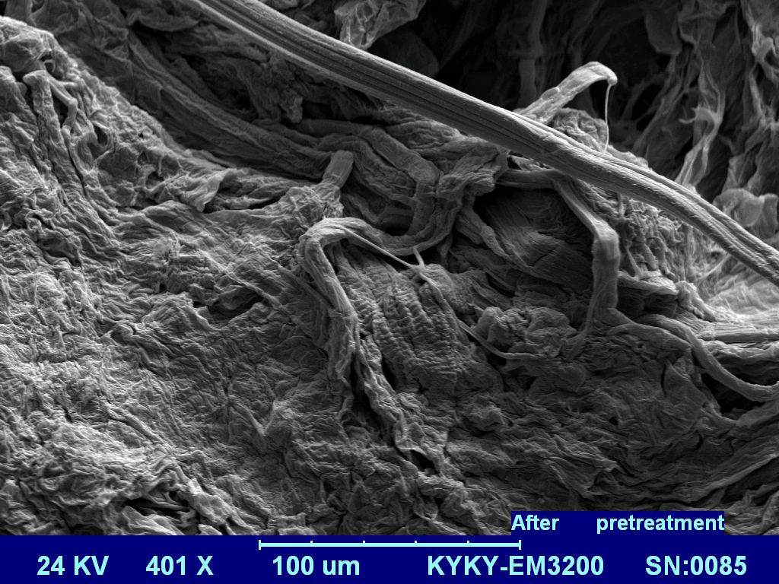
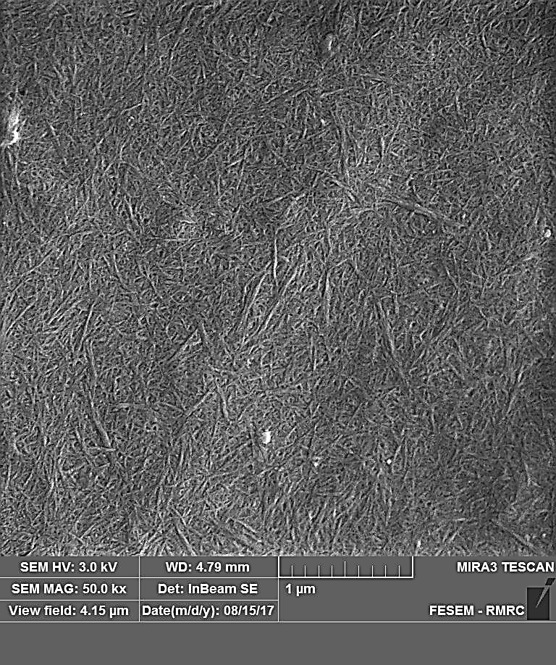
(a)
(b)

Figure 1. (a) SEM image of the bleached cellulose pulp and (b) FESEM image of CNFs.

The topography of the isolated CNFs attained from AFM analysis can be observed in Figure 2. There can be seen an agreement between the morphology of the individual nanofibers and the images attained using electron microscopy. The average diameter of the CNFs was calculated 43 nm, by measuring the 10 cross-section profiles. What is more, the length of nanofibers was found to be in the range of micrometer.

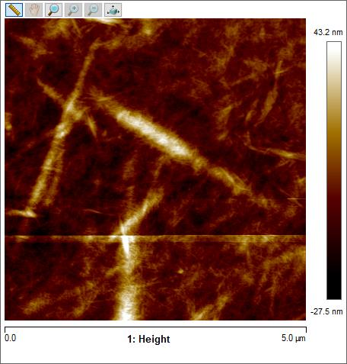

Figure 2. AFM image of the CNFs

Figure 3 shows the absorption spectra of CNF and CNF-AuNP obtained by UV-VIS. This analysis has been done as a preliminary test for investigating the correctness of the method applied to synthesize AuNPs on the CNF. As can be observed, there is a well-defined absorption peak at the ⁓530 nm wavelength, confirming the presence of metallic gold nanostructures as a result of the successful reduction of the gold ions (Migliorini et al., 2020). The interaction between metallic gold nanostructures with electromagnetic radiation concluded in a SPR effect of the collective oscillation conductive electrons from AuNPs in CNF-AuNP and the emergence of the absorption band at ⁓530 nm. It can be concluded that the employed method for the modification of the surface of CNFs by AuNPs has been efficient.

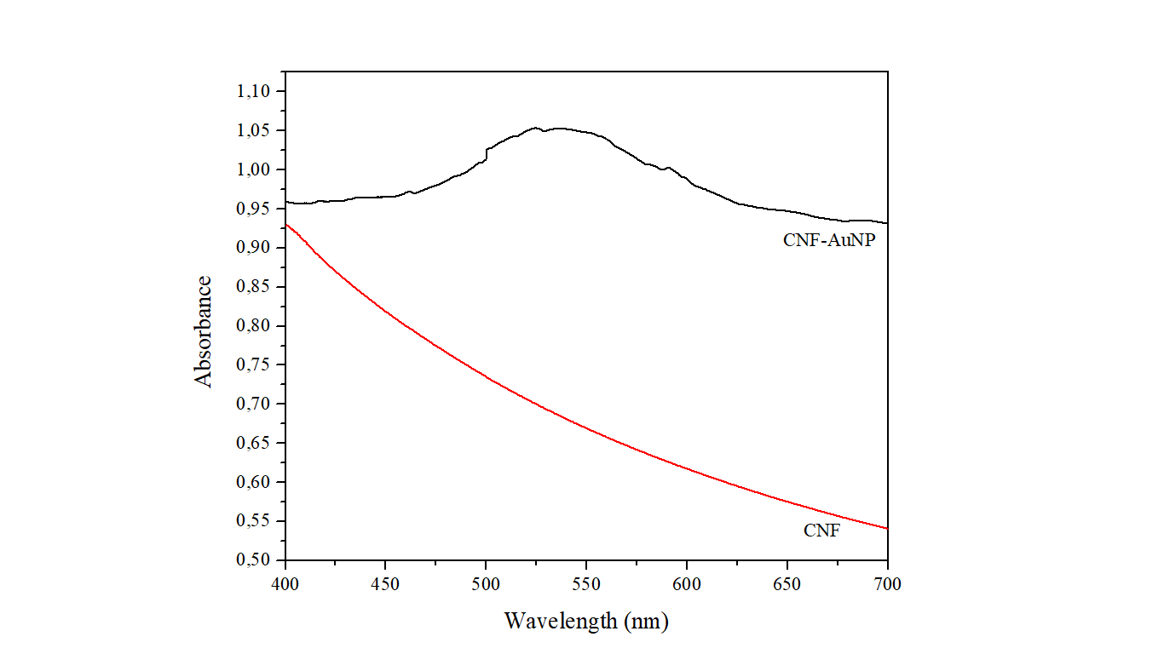

Figure 3. UV-VIS absorption spectra of the CNFs and CNF-AuNP.
The appraisal of the performance of the prepared sensing nanocomposite was conducted by combining it with aqueous solutions of different ionic salts HMIs with the concentration of 600 nM and analyzing them with UV-VIS. The spectra collected by UV-VIS is shown in Figure 4. The changes in the absorption band at ⁓530 nm wavelength prove that the fabricated sensing nanocomposite was able to detect the HMIs. Specifically, the complex formed between the HMIs and sodium citrate was conducive to the formation of AuNP clusters. This phenomenon has led to decrease in the absorbance at 530 nm or a red shift in a plasmonic band.

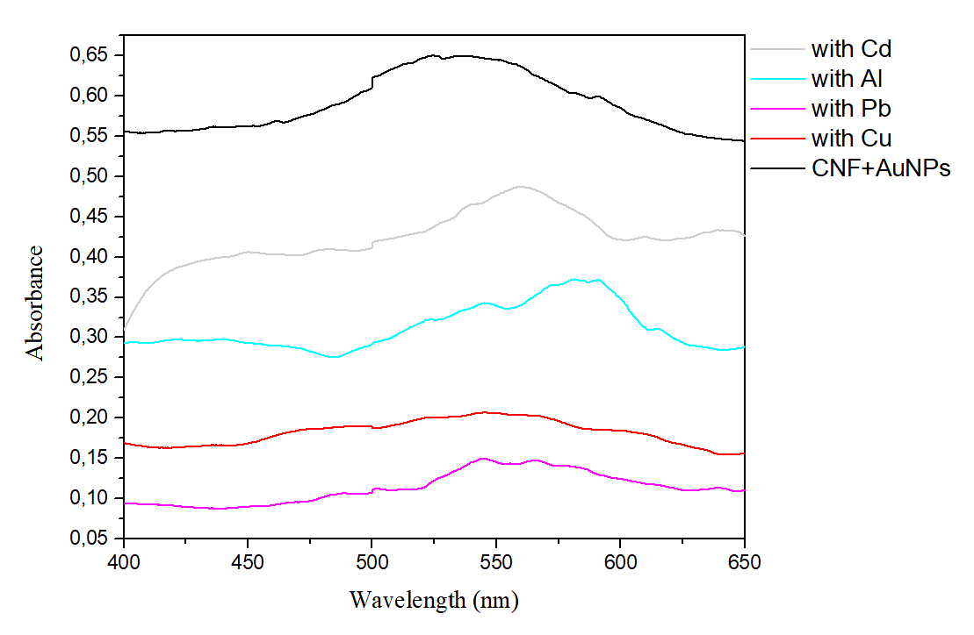

Figure 4. (a) UV-VIS absorption spectra of the CNFs and CNF-AuNP.

  - Conclusions
In this work, CNFs were isolated from bleached cellulose pulp via mechanical treatments. SEM and FESEM images captured from CNFs indicated that the applied technique was able to defibrillate the bleached pulp into individual nanofibers. In addition, the results gained from AFM analysis of CNFs was consistent with the ones of electron microscopy. The image acquired from this analysis showed that they are in the form of individual nanofibers with the estimated average size of 43 nm. The UV-VIS spectrum of the resultant CNFs and CNFs-AuNPs before and after being mixed with the aqueous solutions of Cd²⁺, Pb²⁺, Al³⁺, and Cu²⁺ confirmed the correctness of the utilized method. As a matter of fact, the peak appeared at the wavelength of ⁓530 nm was the evidence of the reduction of gold and the successful synthesis of CNFs-AuNPs. The mechanism of detection was on a basis of the formation of AuNPs cluster in the presence of HMIs (600 nM) resulting in the decrease in absorbance peaks of the spectrum at ⁓530 nm.

Acknowledgments
The authors would like to acknowledge the financial support of the University of the Basque Country (Training of Researcher Staff, PIF 20/197) and the Basque Government (IT1498-22).

References
Ayodhya, D., 2022. A review on recent advances in selective and sensitive detection of heavy toxic metal ions in water using g-C3N4-based heterostructured composites. Mater. Chem. Front. 6, 2610–2650. https://doi.org/10.1039/d2qm00431c
Barja, F., 2021. Bacterial nanocellulose production and biomedical applications. J. Biomed. Res. 35, 310–317. https://doi.org/10.7555/JBR.35.20210036
de Amorim, J.D.P., de Souza, K.C., Duarte, C.R., da Silva Duarte, I., de Assis Sales Ribeiro, F., Silva, G.S., de Farias, P.M.A., Stingl, A., Costa, A.F.S., Vinhas, G.M., Sarubbo, L.A., 2020. Plant and bacterial nanocellulose: production, properties and applications in medicine, food, cosmetics, electronics and engineering. A review. Environ. Chem. Lett. 18, 851–869. https://doi.org/10.1007/s10311-020-00989-9
Ge, Y., Li, Z., 2018. Application of Lignin and Its Derivatives in Adsorption of Heavy Metal Ions in Water: A Review. ACS Sustain. Chem. Eng. 6, 7181–7192. https://doi.org/10.1021/acssuschemeng.8b01345
Guo, G., Niu, G., Shi, Q., Lin, Q., Tian, D., Duan, Y., 2019. Multi-element quantitative analysis of soils by laser induced breakdown spectroscopy (LIBS) coupled with univariate and multivariate regression methods. Anal. Methods 11, 3006–3013. https://doi.org/10.1039/c9ay00890j
Guo, W., He, H., Zhu, H., Hou, X., Chen, X., Zhou, S., Wang, S., Huang, L., Lin, J., 2019. Preparation and properties of a biomass cellulose-based colorimetric sensor for Ag+ and Cu2+. Ind. Crops Prod. 137, 410–418. https://doi.org/10.1016/j.indcrop.2019.05.044
Han, F., Huang, X., Teye, E., 2019. Novel prediction of heavy metal residues in fish using a low-cost optical electronic tongue system based on colorimetric sensors array. J. Food Process Eng. 42, 1–9. https://doi.org/10.1111/jfpe.12983
Baraka, F. Robles, E., Labidi, J., 2023. Industrial Crops & Products Microwave-assisted esterification of bleached and unbleached cellulose nanofibers a Biorefinery. Ind. Crop. Prod. 191, 115970. https://doi.org/10.1016/j.indcrop.2022.115970
Liu, D., Ding, C., Chi, F., Pan, N., Wen, J., Xiong, J., Hu, S., 2019. Polymer brushes on graphene oxide for efficient adsorption of heavy metal ions from water. J. Appl. Polym. Sci. 136, 1–9. https://doi.org/10.1002/app.48156
Ma, T., Hu, Xinna, Lu, S., Liao, X., Song, Y., Hu, Xiaosong, 2022. Nanocellulose: a promising green treasure from food wastes to available food materials. Crit. Rev. Food Sci. Nutr. 62, 989–1002. https://doi.org/10.1080/10408398.2020.1832440
Mahmoud, A.M., Mahnashi, M.H., Alkahtani, S.A., El-Wekil, M.M., 2020. Nitrogen and sulfur co-doped graphene quantum dots/nanocellulose nanohybrid for electrochemical sensing of anti-schizophrenic drug olanzapine in pharmaceuticals and human biological fluids. Int. J. Biol. Macromol. 165, 2030–2037. https://doi.org/10.1016/j.ijbiomac.2020.10.084
Migliorini, F.L.G. gold nanoparticles supported on cellulose nanowhiskers for easy-to-interpret colorimetric detection of cadmium (II), Teodoro, K.B.R., Correa, D.S., 2020. Green-synthesized gold nanoparticles supported on cellulose nanowhiskers for easy-to-interpret colorimetric detection of cadmium (II). Cellul. Chem. Technol. 54, 407–411. https://doi.org/10.35812/CelluloseChemTechnol.2020.54.41
Omran, A.A.B., Mohammed, A.A.B.A., Sapuan, S.M., Ilyas, R.A., Asyraf, M.R.M., Koloor, S.S.R., Petrů, M., 2021. Micro-and nanocellulose in polymer composite materials: A review. Polymers (Basel). 13, 1–30. https://doi.org/10.3390/polym13020231
Pires, J.R.A., Souza, V.G.L., Fernando, A.L., 2019. Valorization of energy crops as a source for nanocellulose production – Current knowledge and future prospects. Ind. Crops Prod. 140, 111642. https://doi.org/10.1016/j.indcrop.2019.111642
Pohl, A., 2020. Removal of Heavy Metal Ions from Water and Wastewaters by Sulfur-Containing Precipitation Agents. Water. Air. Soil Pollut. 231. https://doi.org/10.1007/s11270-020-04863-w
Punia, P., Bharti, M.K., Dhar, R., Thakur, P., Thakur, A., 2022. Recent Advances in Detection and Removal of Heavy Metals from Contaminated Water. ChemBioEng Rev. 9, 351–369. https://doi.org/10.1002/cben.202100053
Thakur, V., Guleria, A., Kumar, S., Sharma, S., Singh, K., 2021. Recent advances in nanocellulose processing, functionalization and applications: A review. Mater. Adv. 2, 1872–1895. https://doi.org/10.1039/d1ma00049g
Torres, F.G., Troncoso, O.P., Gonzales, K.N., Sari, R.M., Gea, S., 2020. Bacterial cellulose‐based biosensors. Med. Devices Sensors 3, 1–13. https://doi.org/10.1002/mds3.10102
Trache, D., Tarchoun, A.F., Derradji, M., Hamidon, T.S., Masruchin, N., Brosse, N., Hussin, M.H., 2020. Nanocellulose: From Fundamentals to Advanced Applications, Frontiers in Chemistry. https://doi.org/10.3389/fchem.2020.00392
Turkevich, J., Stevenson, P.C., Hillier, J., 1951. A study of the nucleation and growth processes in the synthesis of colloidal gold. Discuss. Faraday Soc. 11, 55–75. https://doi.org/10.1039/DF9511100055
Wen, J., Zhang, W., Xu, Y., Yu, Y., Lin, X., Fu, M., Liu, H., Peng, J., Zhao, Z., 2022. Cellulose nanofiber from pomelo spongy tissue as a novel particle stabilizer for Pickering emulsion. Int. J. Biol. Macromol. 224, 1439–1449. https://doi.org/10.1016/j.ijbiomac.2022.10.230

